**P4 meets 5G**

**Authors: Sándor Laki1, Péter Vörös1, Róbert Kitlei1, Máté Tejfel1, Gergely Pongrácz2  
Affiliations: 1 ELTE Eötvös Loránd University, Hungary; 2 Ericsson Research, Budapest, Hungary  
On site presenters: Péter Vörös, Sándor Laki (**[**lakis@elte.hu**](mailto:lakis@elte.hu)**)**

In this demo, we show the new capabilities of the open source P4 compiler called T4P4S-16 [1] (pronounced as “tapas”) developed by our research group at ELTE [3]. Its new features (including the support of P4-16) will be demonstrated through a complex telecom use case, namely a 5G UPF (user plane function). The user plane function handles the critical data plane processing of packets between radio access network consisting of user equipments (UEs) and eNodeBs (eNBs) and the data network (e.g. Internet). The 3GPP specification [2] defines a wide set of functionalities associated with the UPF, including access control, **GTP-U tunnel encapsulation/decapsulation**, **bearer lookup**, service data flow (SDF) mapping, per-flow QoS, guaranteed bit rate, **maximum bit rate**, **forwarding of packets to/from packet data network**, etc. In this demo, we will demonstrate how a simplified 5G UPF pipeline (containing functionalities denoted by bold face) shown in Fig. 1 can be implemented in P4-16 (based on v1model).

Using the T4P4S-16 compiler with DPDK backend the generated switch program will 1) show the operation with emulated uplink and downlink traffic generated by different number of users and 2) introduce the new features of T4P4S-16 and 3) demonstrate the packet processing performance of the generated switch program under realistic emulated traffic with various load levels. During the demo, a simple web interface will display the important metrics like the ingress and egress traffic rates (total and per user), number of user, number of CPU cores used, processing delay, etc. in real time. The demo experiments will be carried out in our remote testbed consisting of a switch node and a tester node generating realistic test traffic and multiple 10Gbps links between them.

 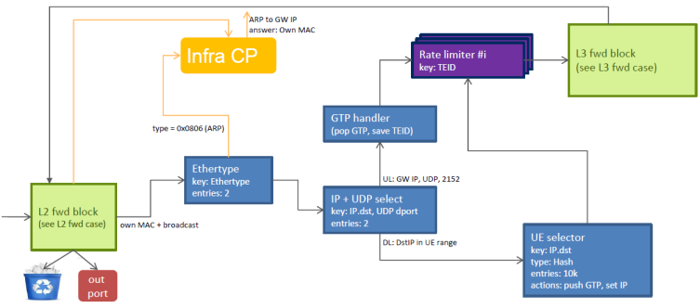  
a) b)  
**Figure 1**: a) A simplified network topology with traffic movement through an UPF. b) High level description of the UPF pipeline.

**References:**  
[1] T4P4S-16, url: <https://github.com/P4ELTE/t4p4s/tree/t4p4s-16>  
[2] Agiwal, Mamta, Abhishek Roy, and Navrati Saxena. "Next generation 5G wireless networks: A comprehensive survey." IEEE Communications Surveys & Tutorials 18.3 (2016): 1617-1655.  
[3] Our project site: <http://p4.elte.hu/>